Task 2 AIDDS
1)Nine Pillars Technique
Q1)Why is using AI Development Agent (like Gemini CLI)for repetitive setup tasks better for your growth as a system architect?
Ans)Ai Development Agent Jo repetitive tasks ka setup khoud bana kr deay deayta hai, is say time bachta hai or developer sirf system ka design or architect par focus kr layta hai .
Q2)Explain how the nine Pillars of AIDD help a developer grow into an M shaped developer?
Ans)Nine Pillars m specification,testing,automation, planning or AI ke saath kaam kerna shamil hota hai, y sb mil kr apko sirf ak skill m hi involve nhi hona deayta hai bilka ap different fields ki skills m bhi strong hu jayta hu ,Jo ap ko M Shaped developer banate hai.
2) VIBE CODING VS SPECIFICATION DRIVEN DEVELOPMENT
Q1:Why does vibe coding usually create problems after one week?
Ans)Vibe coding m developer sirf idea or experiment par kaam kerta hai kwey structure y plan nhi banta hai jis ki waja say 1 week ka baad code m error ,bug or code m maintability nhi rahti hai q ka developer na kwey proper structure y plan nhi banya hota hai.
Q2:How would specification driven development prevent those problems?
Ans) specification driven development m phala ak clear structure banata hai phir AI and developer mil kr us structure ko follow kerta hai, is say future m code m bug or error kaam ayta hai or is say y hota hai jo software banya hai wo bhout reliable hota hai .
3) Architecture Thinking 🤔
Q1)How does architecture first thinking change the role of a developer in AIDD?
Ans) Architecture first thinking m developer sirf code nhi likhta hai,balki structure layer or design par bhi focus kerta hai, developer AI ko guide kerta hai Jo system Tum bana raha hu wo reliable or structure ho
Q2) Explain why developer must think in layers and systems instead of raw code ?
Ans) Agar developer sirf raw code par focus kerta hai tu us say code messay and unstructured hota hai ,layer and system m sochne say Jo software hum banta hai wo AI ka Sath mil kr easily work kerta hai.
PART B
CLI PROMPT
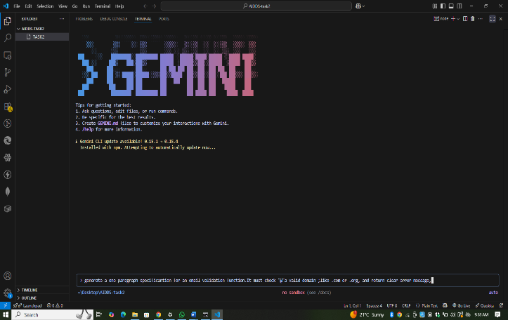
AI-GENERATED SPECIFICATION
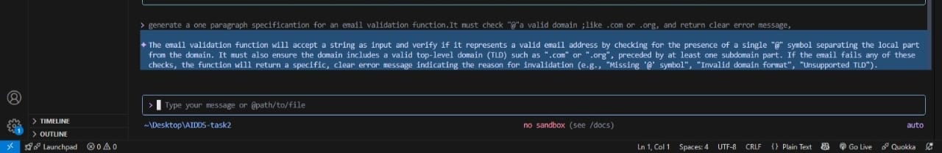

PART C (MCQS)
1)What is the main purpose of Spec-Driven Development?
✅ B. Clear requirements before coding begins
2. What is the biggest mindset shift in AI-Driven Development?
✅ B. Thinking in systems and clear instructions
3. Biggest failure of Vibe Coding?
✅ B. Architecture becomes hard to extend
4. Main advantage of using AI CLI agents (like Gemini CLI)?
✅ B. Handle repetitive tasks so dev focuses on design & problem-solving
5. What defines an M-Shaped Developer?
✅ C. Deep skills in multiple related domains

